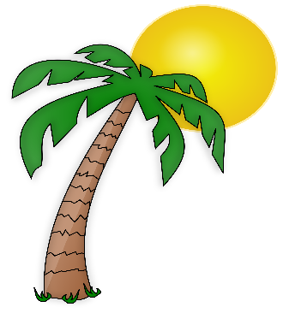
Palm Bay Schools
Grades 9-12
Supply List 2021-22
History Courses
1.5’’ Binder

5 tab dividers

Pencils

Pens (at least 1 red)

Pack of colored pencils

Composition notebook

Paper

3 Expo markers

Math Courses
1.5’’ Binder

5 tab dividers

Pencils

Spiral notebook

3 Expo markers

English Courses
1.5’’ Binder
5 tab dividers
Pencils #2
Pack of colored pencils
Spiral or Composition notebook
3 Prong folder
3 Expo markers
Highlighters

Elective Courses
1’’ Binder
Paper
Pens
Pencils
Highlighters
3 Expo Markers
3 Prong Folder

Science Courses
1.5’’ Binder
5 tab dividers
Pencils #2
Pack of colored pencils
Spiral or Composition notebook
3 Prong folder
3 Expo markers

