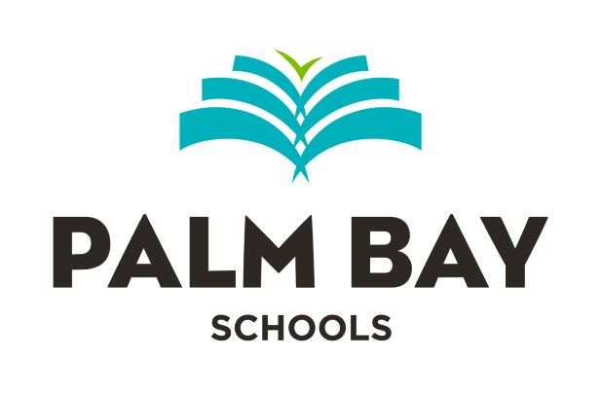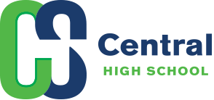

PALM BAY EDUCATION GROUP, INC.
JANUARY 25, 2024 BOARD MEETING

MEMORANDUM

Pursuant to Board approval, an in-the-shade special meeting is currently scheduled for Thursday, January 25, 2024 at 5:00 p.m. to discuss the case of: Palm Bay Education Group, Inc. and The Guarantee Company of North America USA vs. Hagerty Consulting Services, Inc.; Case No. 23001200CA.

The meeting will be attended by the School Board, the Board Attorney, the Executive Director, and Mike Dickey, Esquire.

